**BookBuses**

**Functional Scope:**

**User:**

* User have to do register user details for bus booking
* Once user got login authentication, user can book a bus based on, Bus availability Bus cost,
* Once user book a bus, in user drop down, user can check booked details in booking history
* User can change password
* User want change details of user, in user profile user can edit and update details

**Admin:**

* Admin have individual login authentication
* Admin view registered user details , also admin can delete/Reject user
* In admin page, admin can view bus list, in bus list admin can view, edit, delete buses
* Admin can add routes, after admin can add bus based on routes
* Admin can view bus booking history,

**Technical Scope:**

* Created Controller for admin, bus, user, reservation
* Handle common exception handling
* Created Repository for bus, reservation, route, user
* Created service for individual for admin, user, reservation, route, followed by implementation for all
* Handle all login implementation handled here,
* Handle user login, view edit, update,
* Used Html, css, java script for front End side
* Used springBoot,hibernate, java for backend
* Using RestController, Mapping concept
* Used authentication for user login, admin login

**Home:**

* In home , we can check book bus button, search bus based on user need

**About:**

* Check history and details of bus booking website

**Contact:**

* In contact, head office contact and district wise contact details

**Book a Ticket:**

* Enter from and destination and date of your journey and enter , get list of buses based on search

**Data Base:**

**Tables:**

* bus
* bus_seq
* collage
* collage_seq
* current_user_session
* reservation
* reservation_seq
* route
* route_seq
* user
* user_seq

**Data Validation:**

* only Login user can book a bus
* only authorized admin can view admin page
* Admin can delete user
* Using old password, we can change/update new password
* Register page-All mandatory field,
* Password should be 6 to 8 degit

**API End Points:**

**Home:** [**http://localhost:63342/Book-My-Bus-main/BusTicketReservationSystem(Frontend)/index.html**](http://localhost:63342/Book-My-Bus-main/BusTicketReservationSystem(Frontend)/index.html)

**Book a Ticket:** [**http://localhost:63342/Book-My-Bus-main/BusTicketReservationSystem(Frontend)/User-Side/bookTicket.html**](http://localhost:63342/Book-My-Bus-main/BusTicketReservationSystem(Frontend)/User-Side/bookTicket.html)

**Login:** <http://localhost:63342/Book-My-Bus-main/BusTicketReservationSystem(Frontend)/User-Side/login.html>

**Register:** <http://localhost:63342/Book-My-Bus-main/BusTicketReservationSystem(Frontend)/User-Side/signup.html>

**Response/Request:**

* http://localhost:8088/Bus/add?key= value
* http://localhost:8088/Query?key= value
* http://localhost:8088/reservation/viewall?key= value
* http://localhost:8088/Bus/viewAllBus?key= value
* http://localhost:8088/Bus/update?key= value
* http://localhost:8088/Bus/delete/id?key= value
* http://localhost:8088/user/delete/id?key= value
* http://localhost:8088/route/add?key= value
* http://localhost:8088/Bus/viewAllBus?key= value
* http://localhost:8088/Bus/viewAllBus?key= value
* http://localhost:8088/admin/login
* http://localhost:8088/user/login
* http://localhost:8088/user/view/userid?key= value
* http://localhost:8088/user/add
* http://localhost:8088/reservation/view/searchId?key= value

**Testing and Quality Assurance:**

Checked before login try to do book a ticket, only registered customer can do book a ticket

Tested login without registration, cannot do without registration

Tested other login credential for admin page, unauthorized alert

Tested to add bus without add route ,cannt able to add bus

**Sample Output :**

* **Register user with user details :**

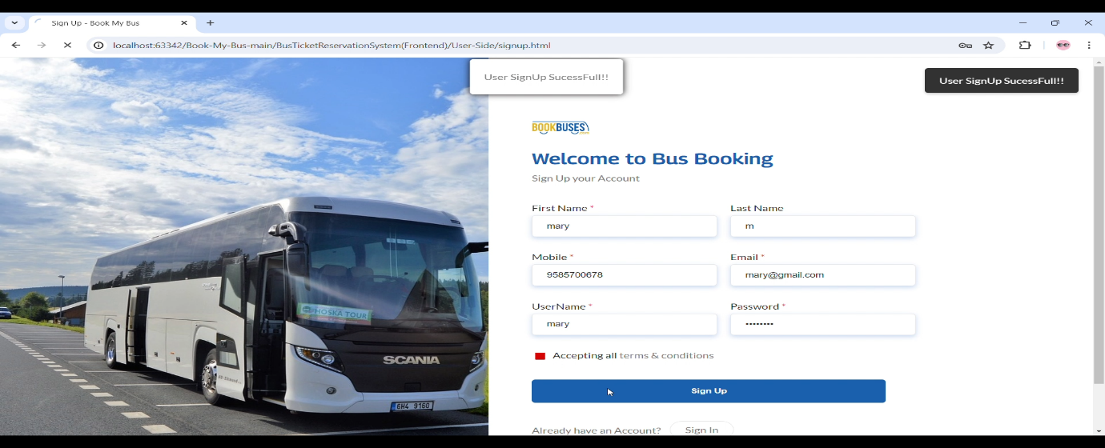

* **User profile updated in DB:**

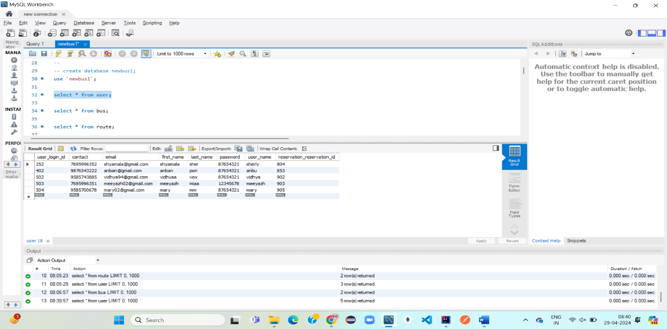

* **Searched bus – Chennai to banglore : total seat -20**

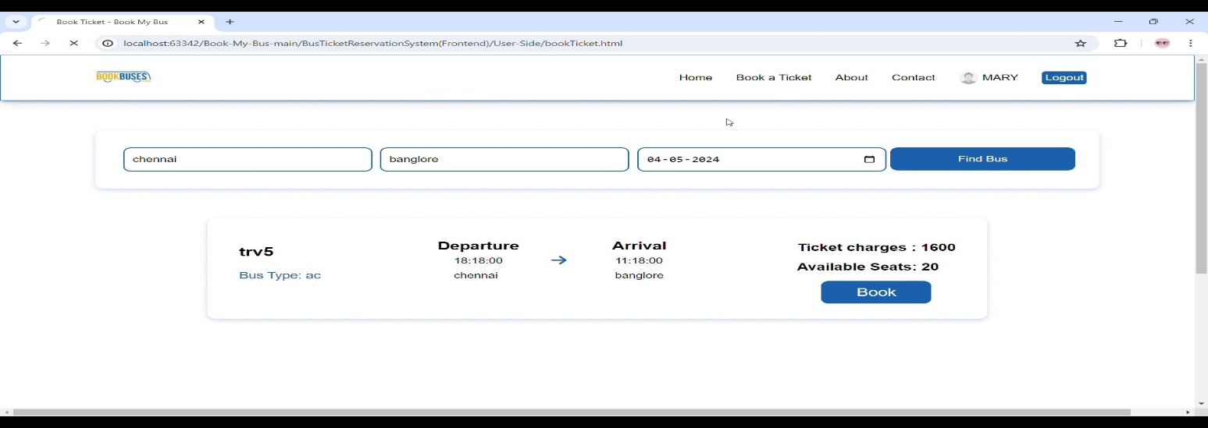

* **After Booked Ticked : total seat -19:**

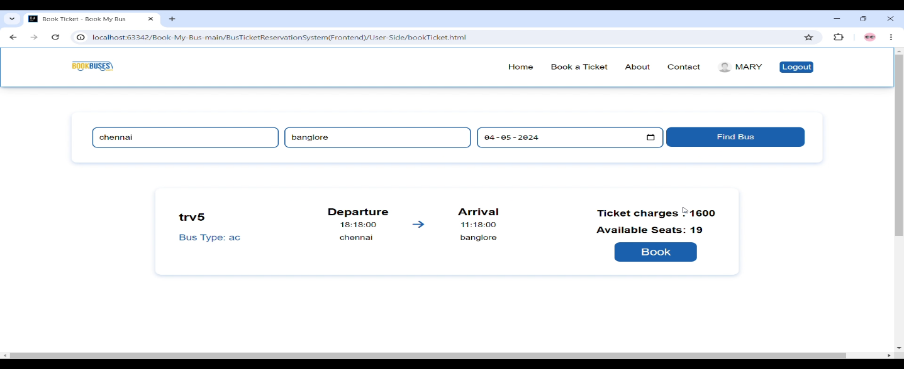

* **Check Booking history for booked details:**

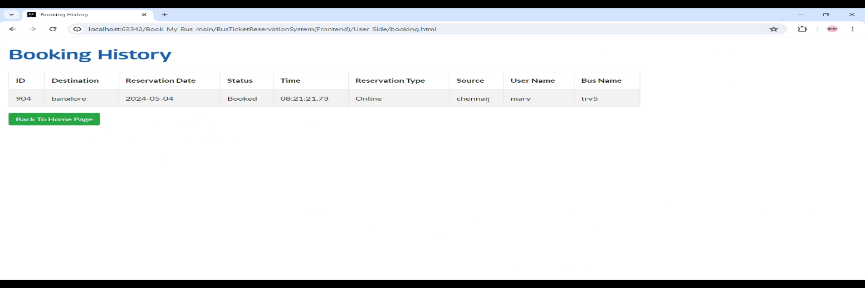

* **Before My Profile :**

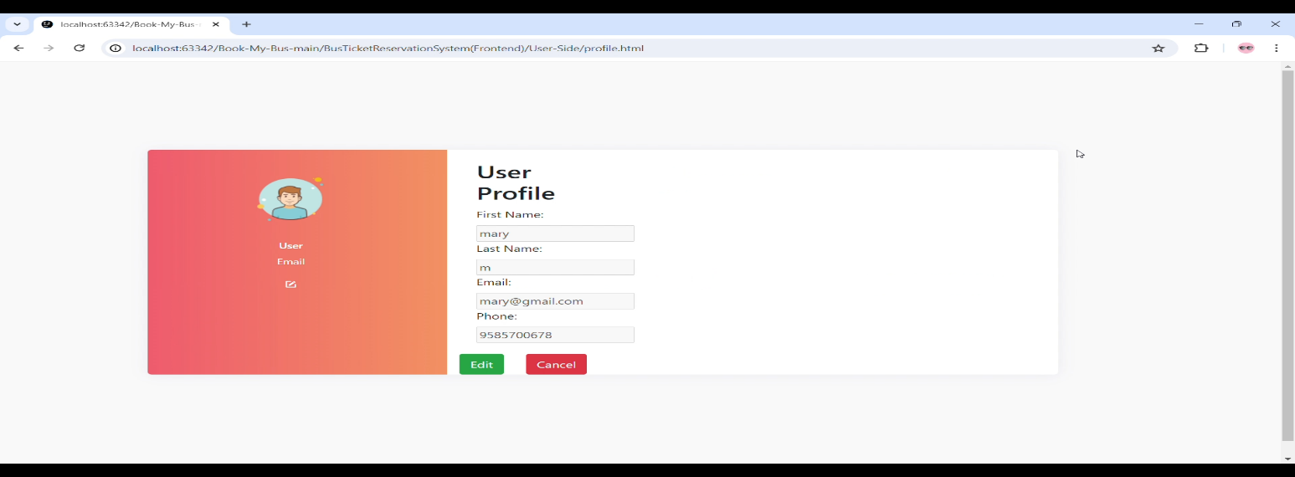

* **After My Profile Updated:**

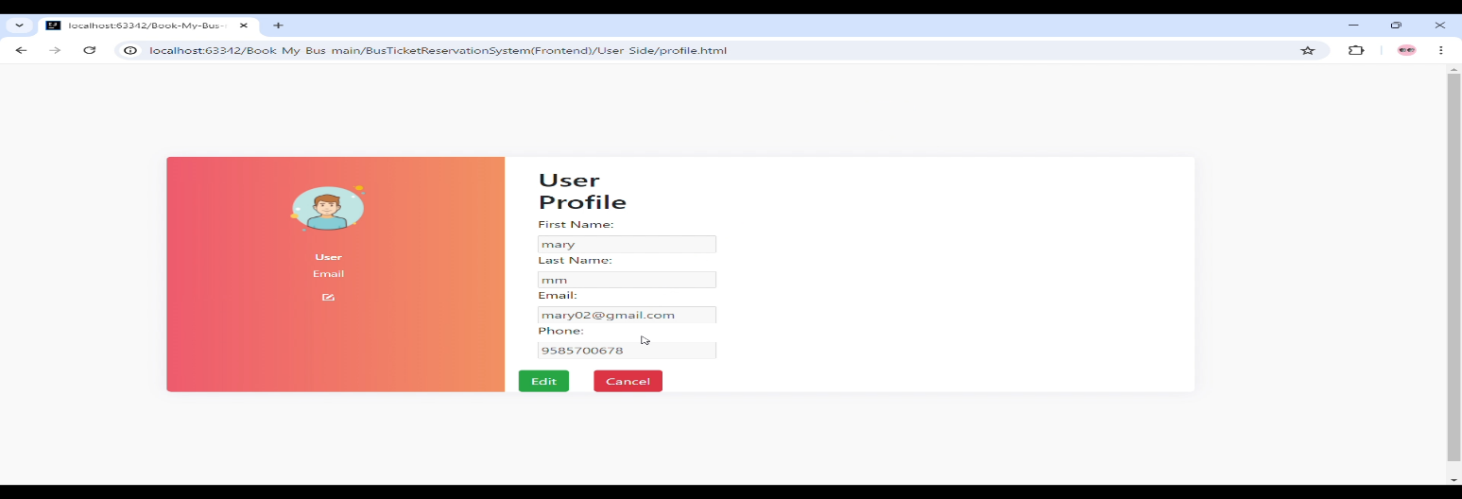

* **Changing password :**

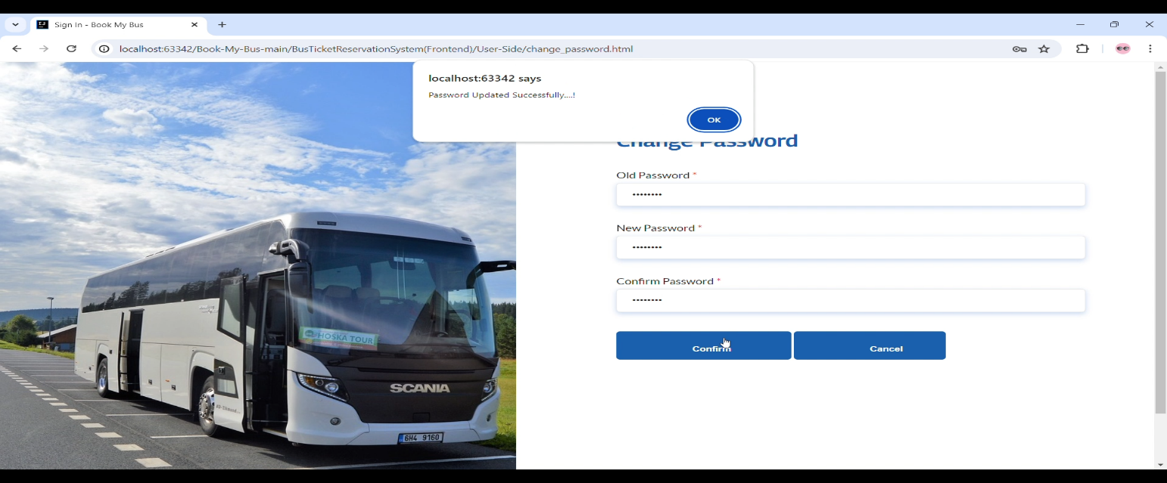

* **Before Password Change DB :**

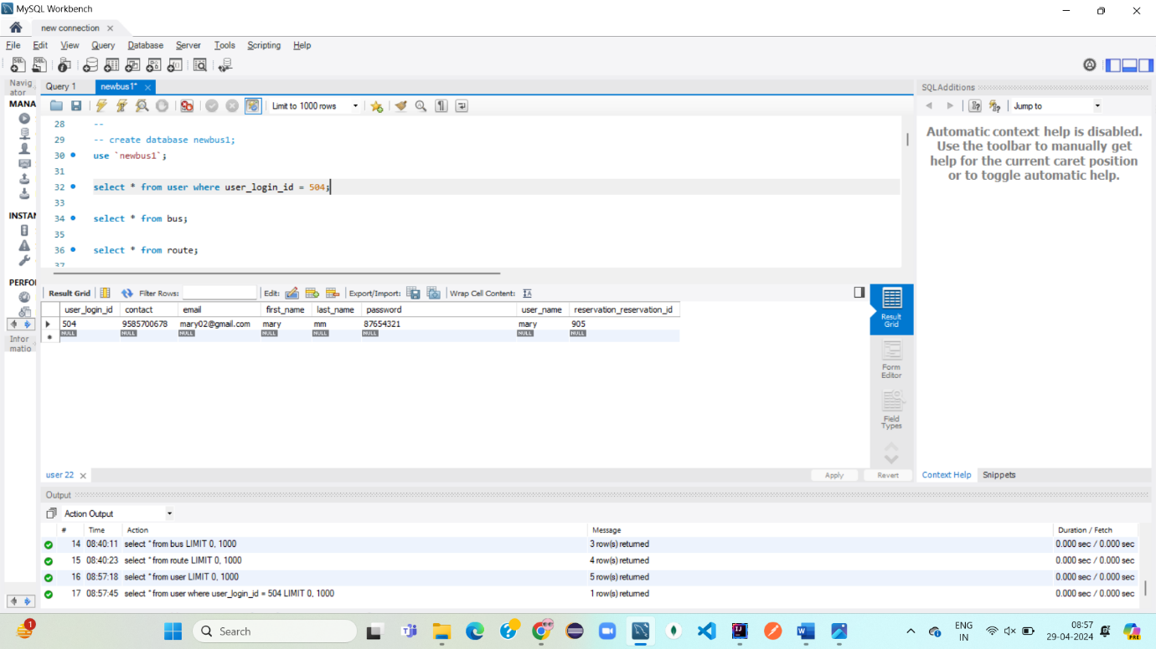

* **After Password changed in DB :**

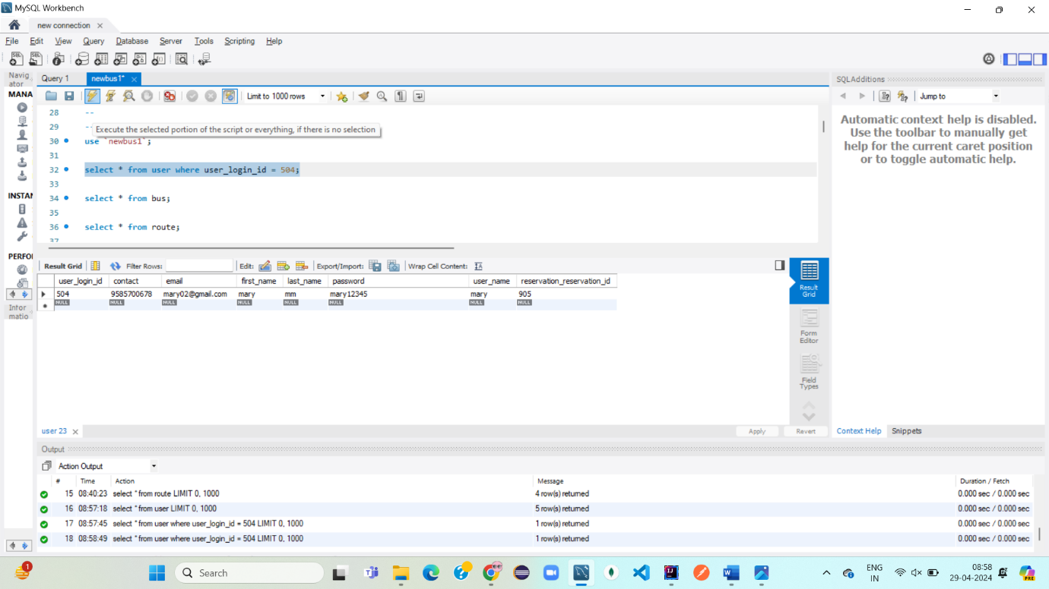

* **Admin Login :**

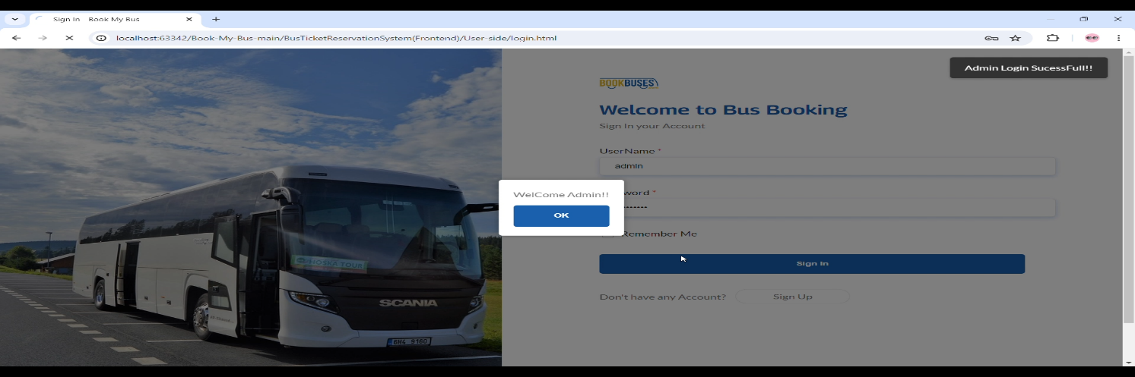

* **Admin can view user registered details in user Panel: User Panel**

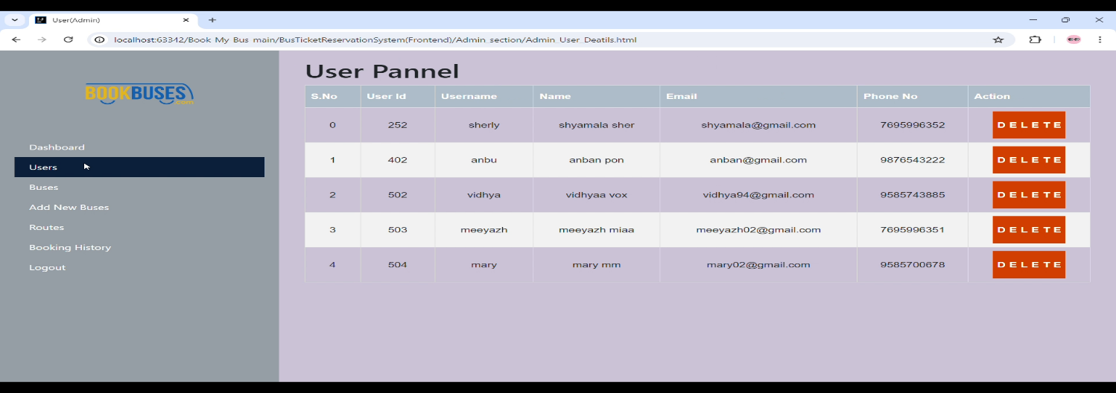

* **Admin can view user Booked details: Booking History**

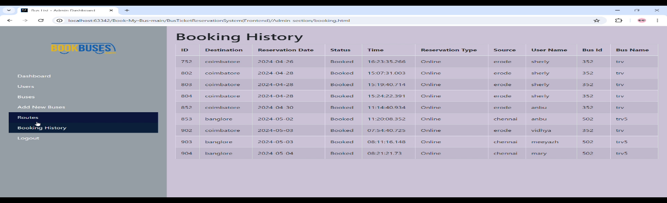

**Admin can add Routes before adding bus : Routes**

* **Admin added route – Chennai to Coimbatore:**

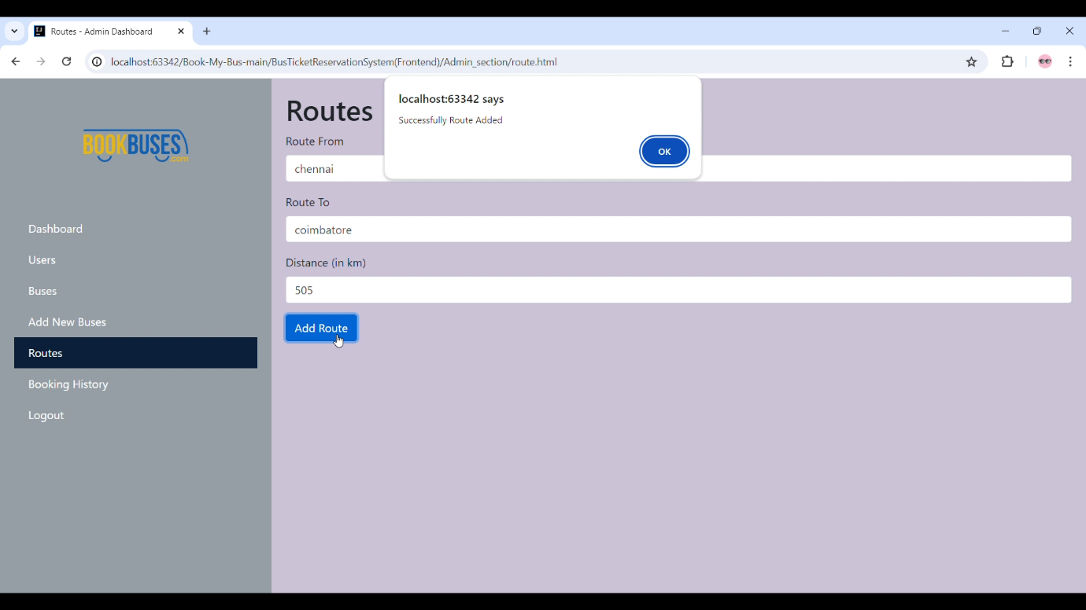

* **Admin added route – Coimbatore to Trichy:**

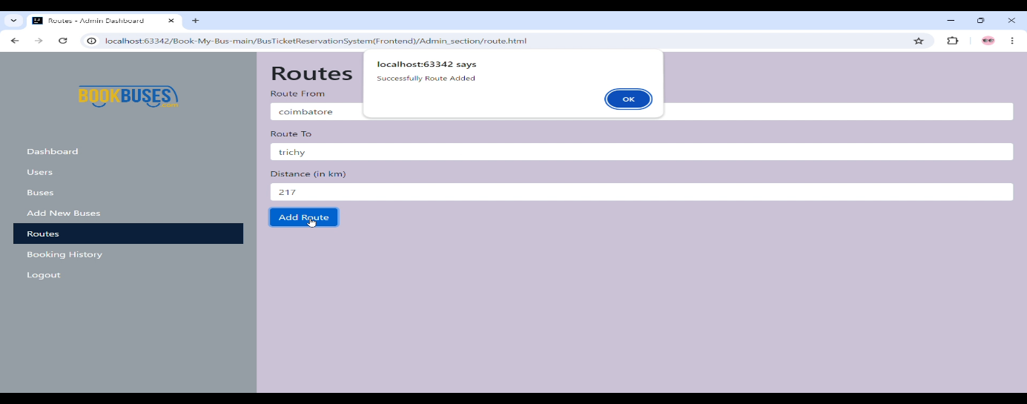

* **Routes Added in DB :**

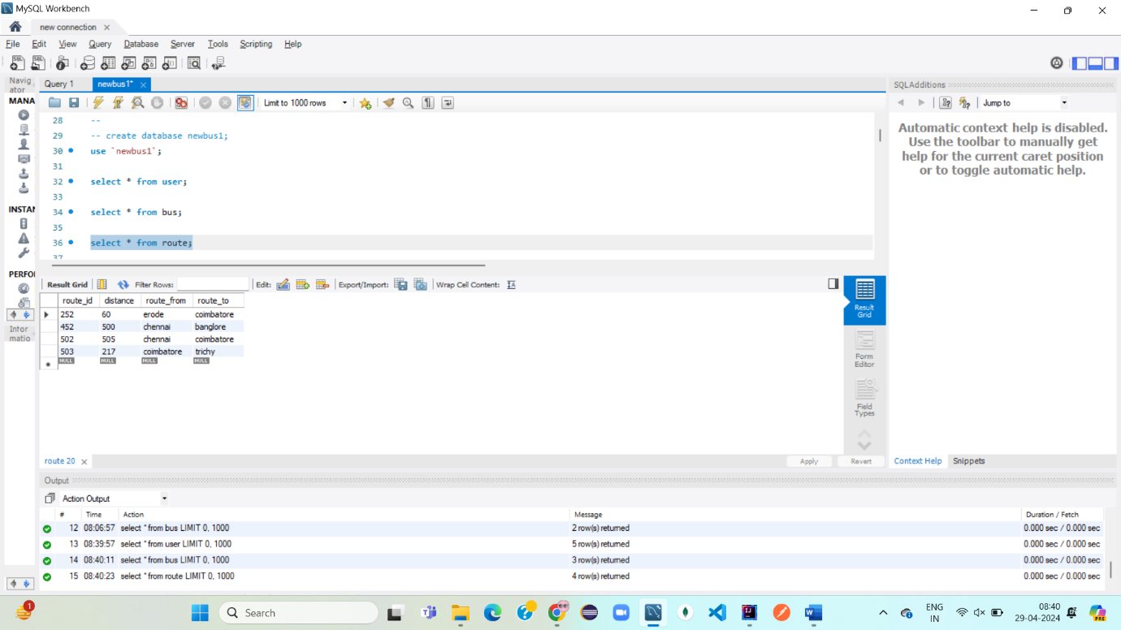

* **Admin Adding bus using routes : Add new Bus**

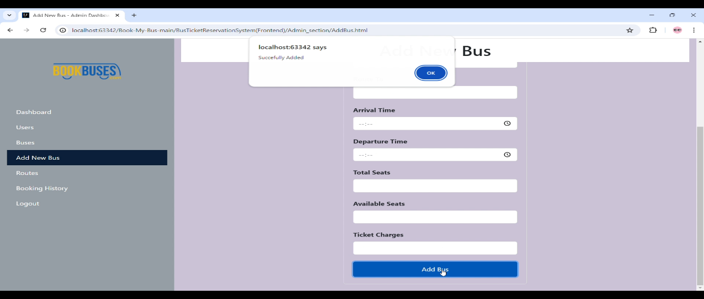

* **New Bus added DB:**

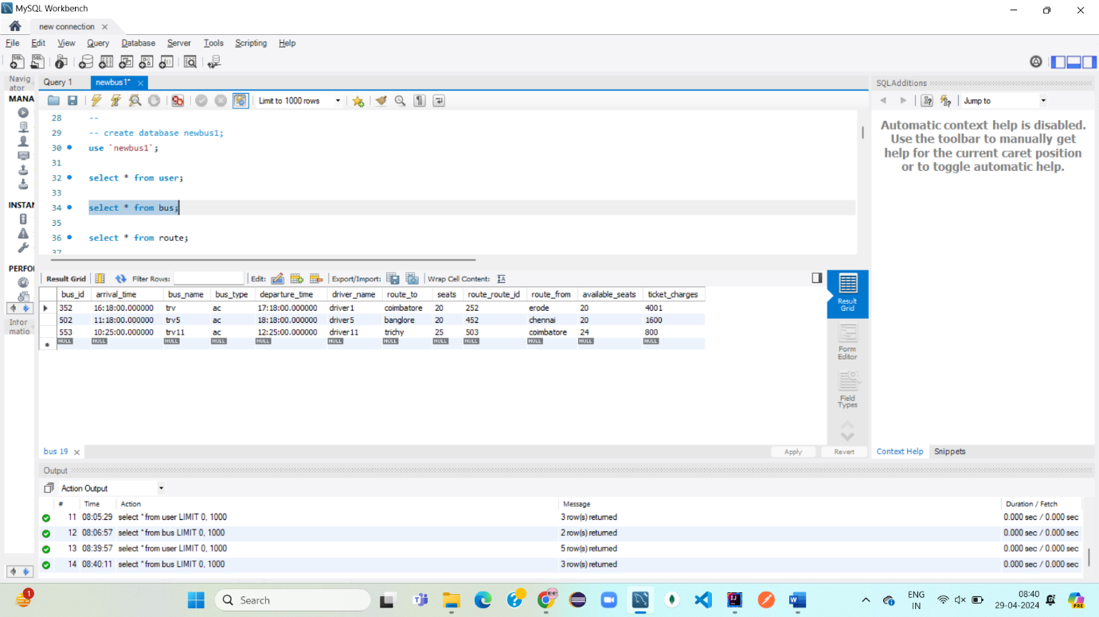

* **Admin can view added new bus in bus list:**
* **Admin can view added new bus in bus list:**

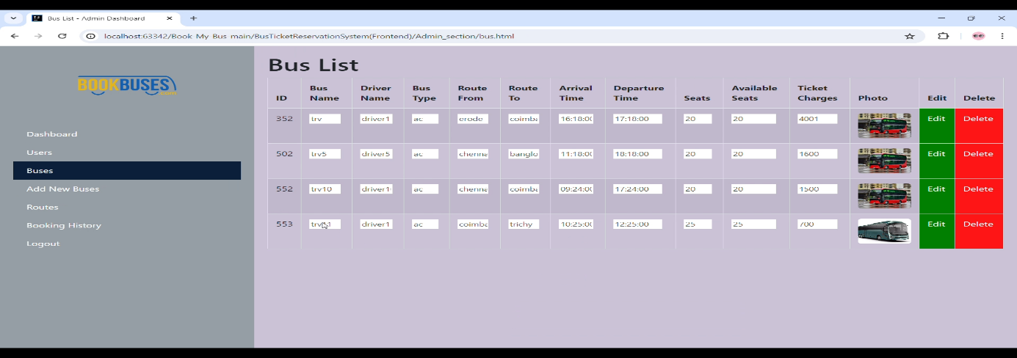

* **Admin can Edit and Save bus details in bus list:**

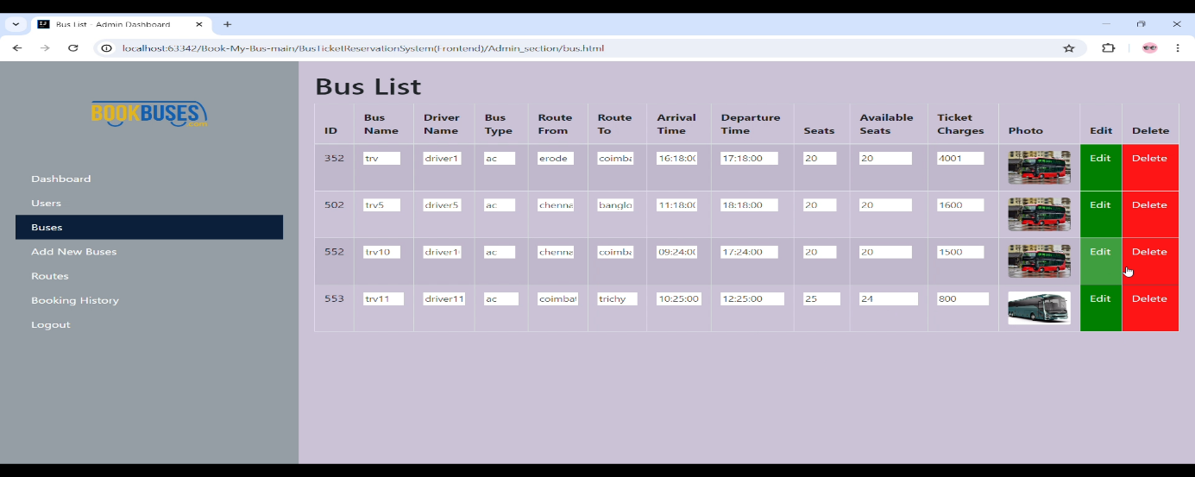

* **Admin can delete bus in bus list:**

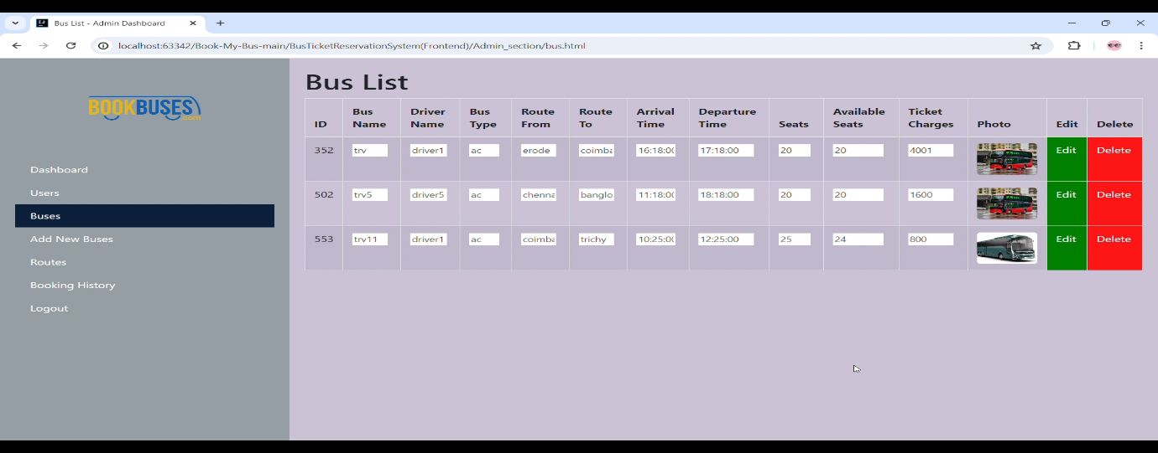

* **User can use - admin added bus :**

